Docker Task -3

Task Description:

Create a custom docker image for nginx and deploy it using docker compose, where the volume bind mount should be at /var/opt/nginx location. Push the created custom docker image to your docker-hub.

Techstacks needs to be used :

- AWS EC2
- Docker
- Docker Compose
Have created a directory, and created docker file,index.html and docker compose file
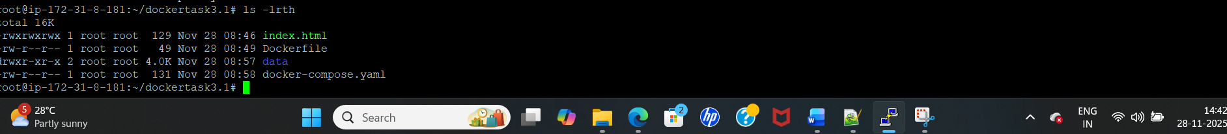

Docker file: - copying customized index html to container html

Docker compose: Mounting volume
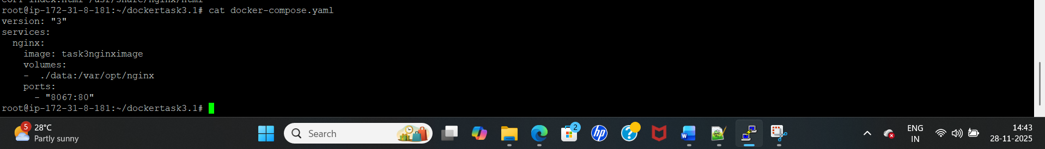
Mounted data:
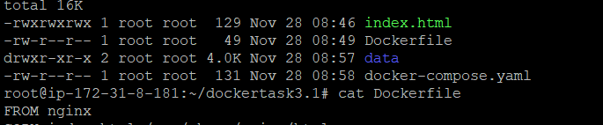
Index.html
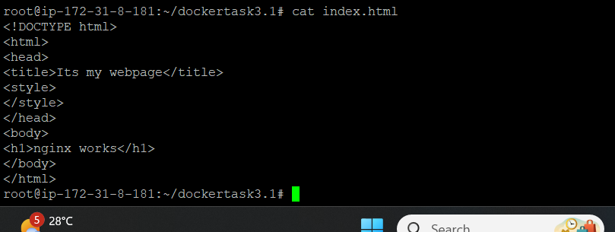
Build the docker file to get the image:
docker build -t task3nginximage .
my docker image is task3nginximage
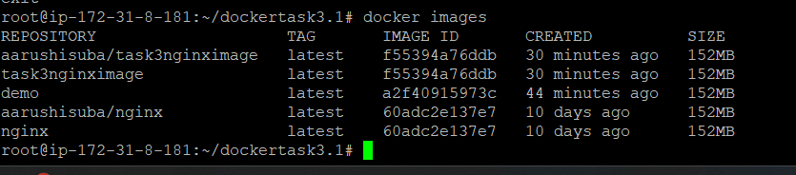
Then I use below commands before start my docker compose up:
14 DOCKER_CONFIG=${DOCKER_CONFIG:-$HOME/.docker}
15 mkdir -p $DOCKER_CONFIG/cli-plugins
16 curl -SL https://github.com/docker/compose/releases/download/v2.5.0/docker-compose-linux-x86_64 -o $DOCKER_CONFIG/cli-plugins/docker-compose
17 apt install docker-compose -y
18 chmod +x $DOCKER_CONFIG/cli-plugins/docker-compose
19 docker-compose version
Docker compose:
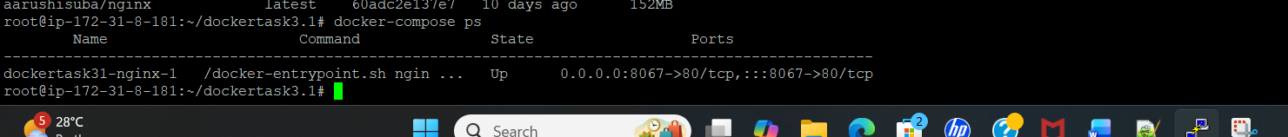

Docker compose is up and trying to connect now webserver:
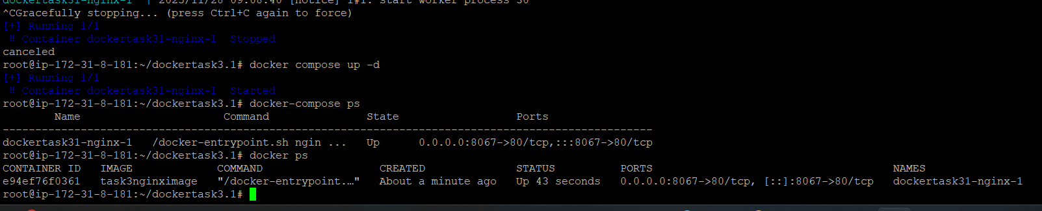
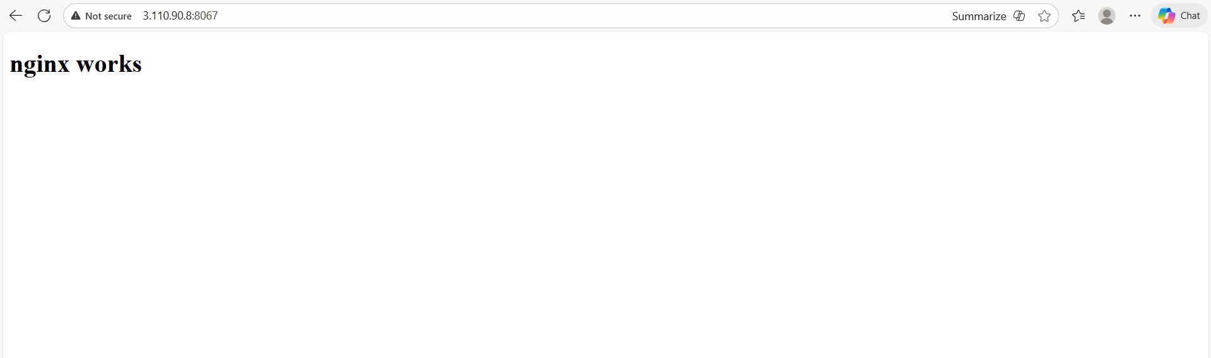

Now, trying to push the image from server to docker hub:
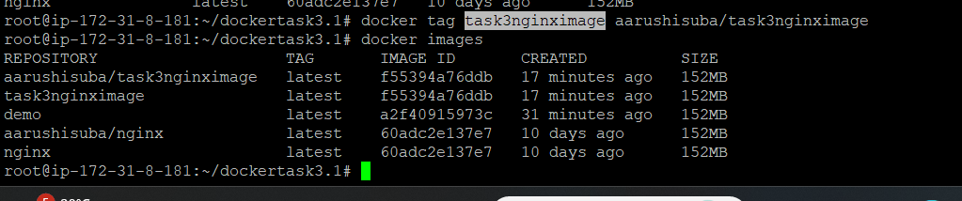
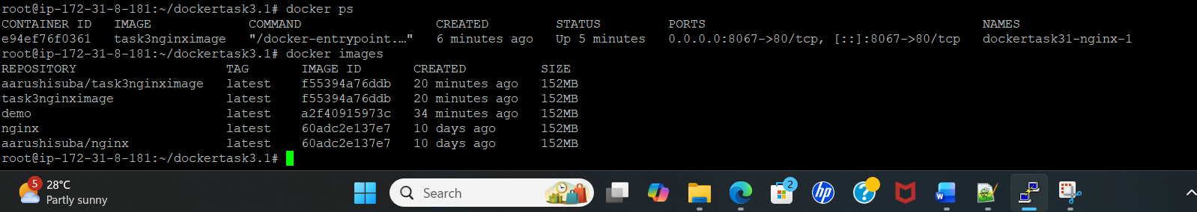

Docker login, did tag and then push:
Docker tag name:
docker tag task3nginximage aarushisuba/task3nginximage
